Steps for setting up Agentforce in community portal

1. Check for Agentforce is enabled in the org, Go to setup>Agentforce for Developer (if not then click on enable) 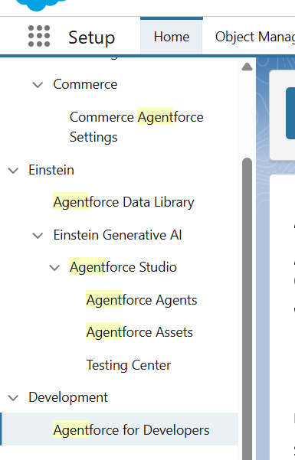
2. Now, In the quick find search for agentforce assets and click ‘+ New Agent’. 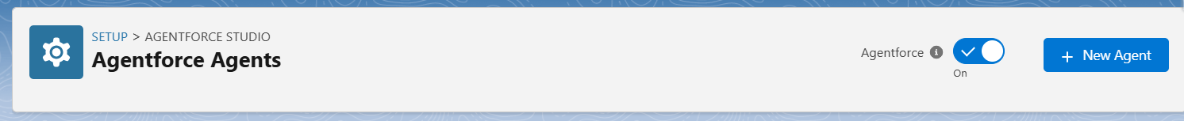
3. Add Name, Description, role, company and select Agent User for the Agent. 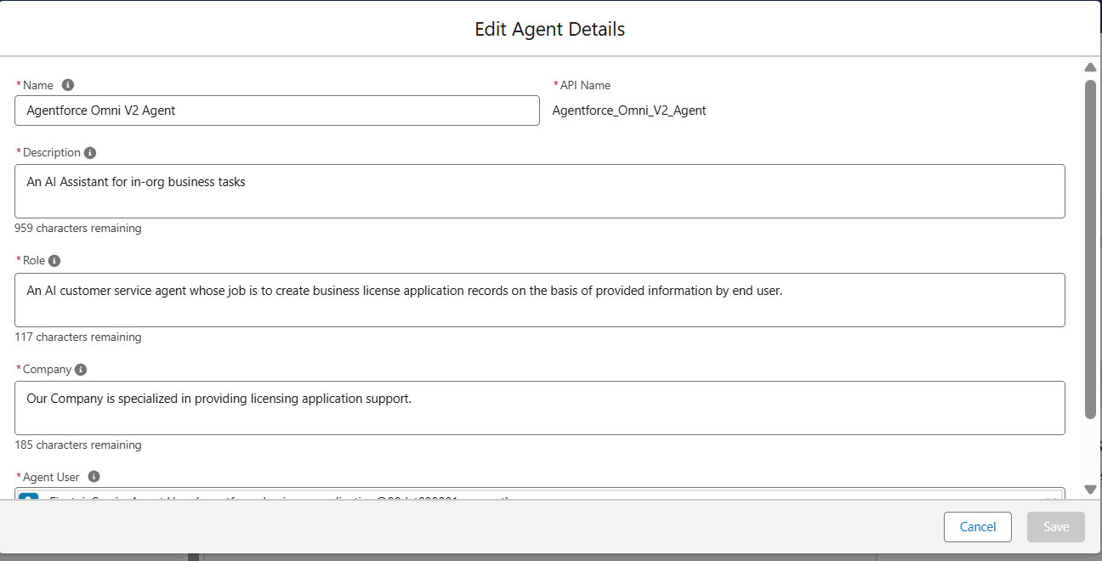
4. Add topics with instructions for agent and click on activate. 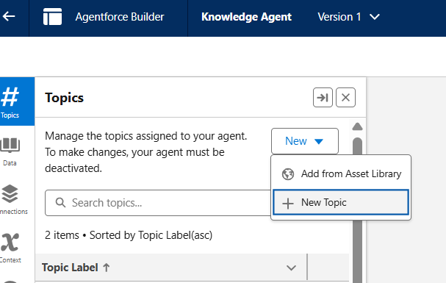
5. Create Routing Configuration, Set Routing Priority to 1, Set Routing Model to ‘Most Available’, Set Units of Capacity to ‘1.00’, Capacity type to ‘Inherited’. 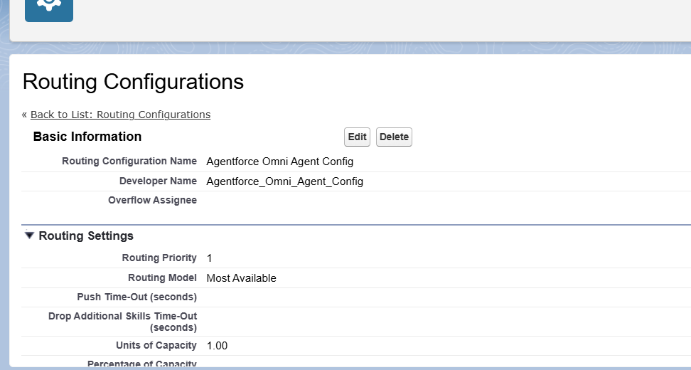
6. Create Queue for routing, Add supported agent equals ‘Messaging Session’ and Add Routing Configuration to Queue and add users to queue.

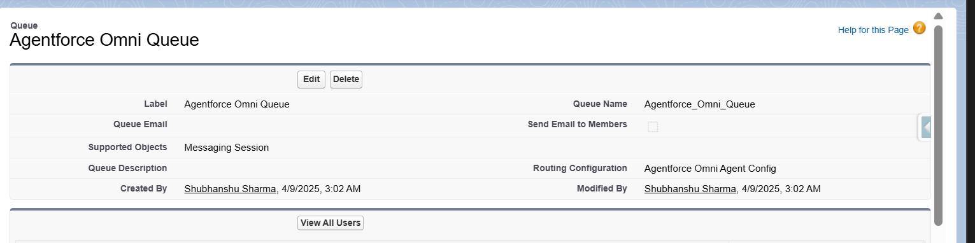

1. Create Service Channel, Go to Setup>Quick find>Messaging Settings>Click on New Channel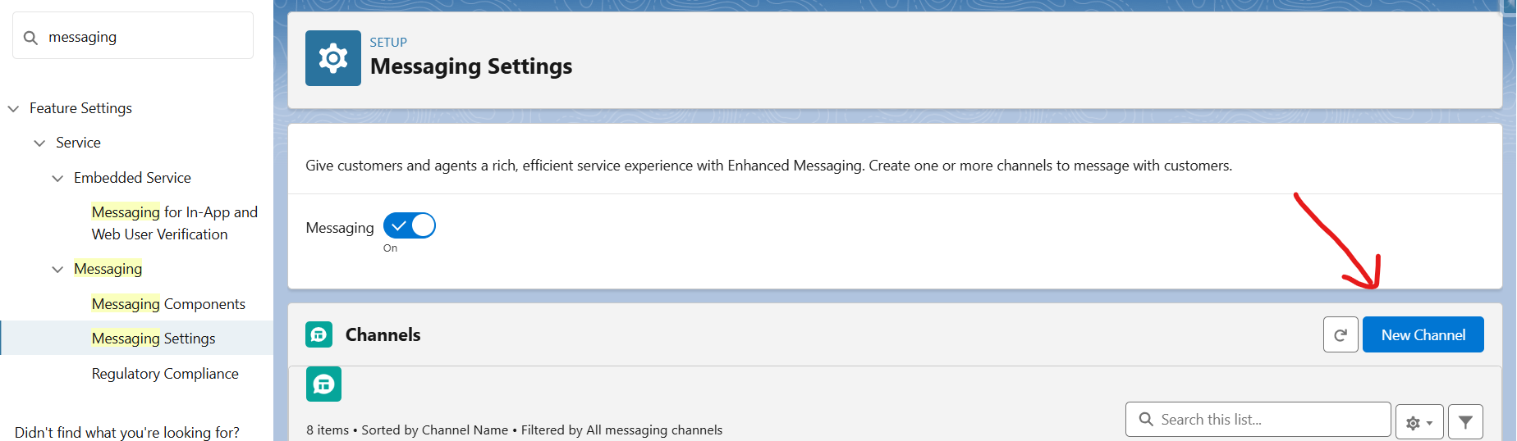
2. Set Omni-Channel Routing, Routing Type equals Omni-Flow, Flow Definition equals Agentforce Omni Routing and Fallback Queue to Agentforce Queue created in Step 6. 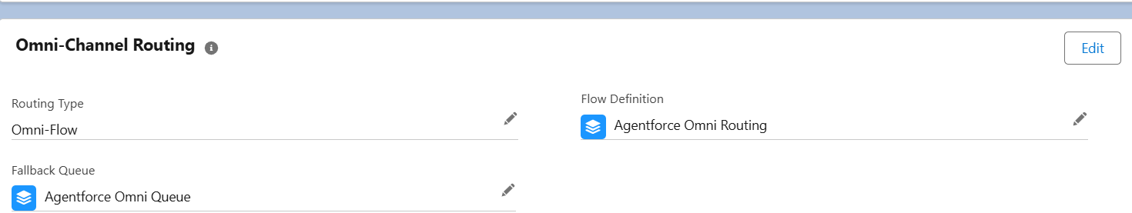
3. Create omni channel flow for agent routing, Add Route Work Component, Set Input Values for ‘How many work records to route?’ To Single, Add text variable with ‘recordId’ apiname to ‘Record ID Variable’, Add Service Channel, Add Agent in ‘Route to’, Select Agent in ‘Agentforce Service Agent’, Add Queue to ‘Fallback Queue’ created in step 6.
4. Click on Activate.
5. Create Embedded Service Deployment Settings, Set Messaging Channel to channel created in Step 7, and click on save.
6. Now, Embedded Service Deployment Settings is created, now click on Edit Settings, Select the ‘Show typing indicators’. 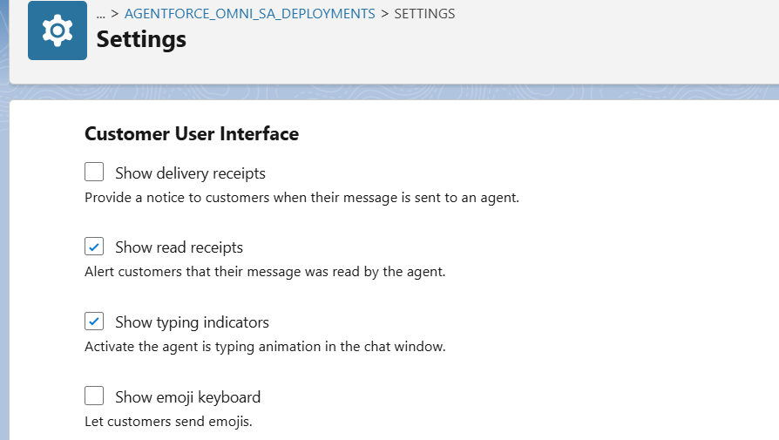
7. Click on Publish, Now it will take 10 minutes to Publish Embedded Service Deployments Settings. 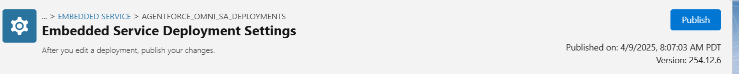

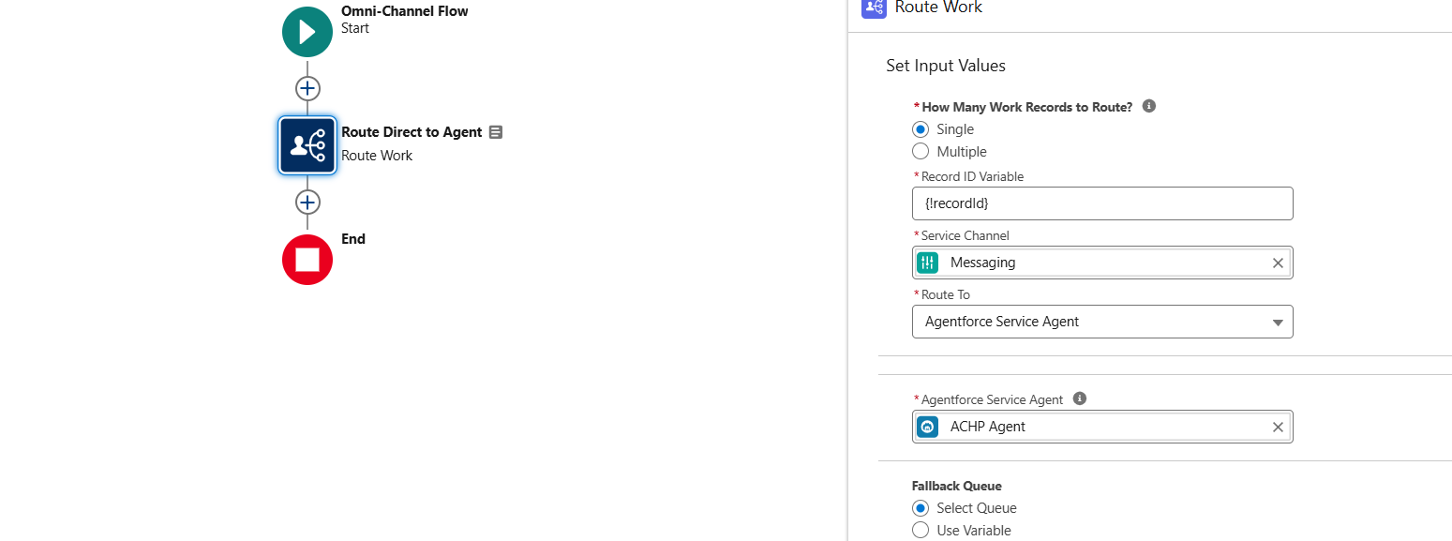

1. Activate the Omnichannel flow.
2. Now Configure CORS, Setup>Quick find>CORS>Click New add Origin URL Pattern to site url. 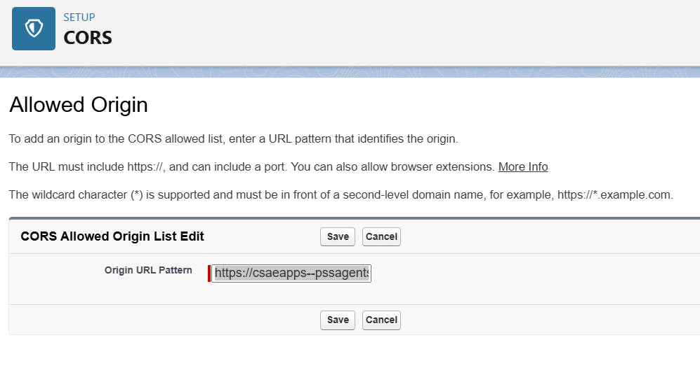
3. Setup Experience Portal for Agent, Click on setup>Quick find>all sites>click on site builder>add Embedded Messaging component on home page. 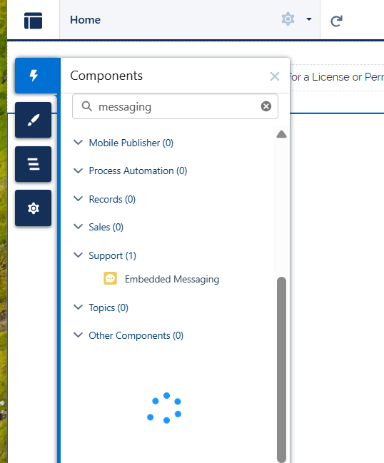
4. Set Embedded Service Deployment settings to embedded messaging component.

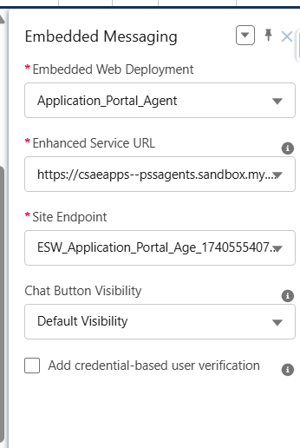

1. Click on Publish.

